I’m impressed with the dedication & focus in bringing back the children to school, I echo their thoughts & approach in short listing each student to ensure their success is unparalleled.

Appreciate this CSR initiative from Law Park Educational Trust!!
Sreekanth
Director
Tech Hat Pvt., Ltd.,

We have known Law Park Educational Trust for few years. It is a genuine and selfless effort of the Trustees to provide financial and other educational resources to children in need with the main goal of right to education regardless of socioeconomic background. I am glad to have known them. I wish them success for continued growth for the greater benefit of children in need.
Best Wishes,
Dr. Varalakshmi and Dr. Nandakumar,
Hershey,
USA

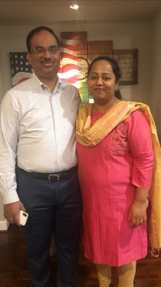

Law Park Education Trust is doing a phenomenal work by facilitating the provision of basic right of education to the underprivileged children of our society and country at large.

This endeavour is a stepping stone towards building a better foundation of our Nation as by imparting knowledge we are creating an educated, informed, civilized and vigilant citizen for tomorrow.
Aishwarya K
Director
Versalis International



Appreciate the efforts of Ms. Charulatha and the trust in helping children's education and myself and my husband are very grateful to be part of this. Many thanks!
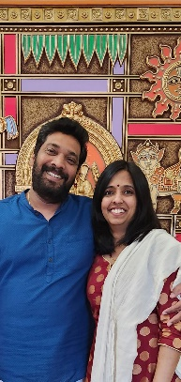
Srividya Vinod
Program Manager
USA

Happy to be associated with LAW PARK EDUCATIONAL TRUST. Your efforts to ensure that under privileged children get good education is commendable. The best way to uplift people is to educate them. I'm very glad to support you in your consistent effort to reaching out to more children for pursuing their education. I'm always happy to help your trust in my best possible ways.
Warm regards
Sangeetha Arun
Partner
INFINPRO CONSULTANTS
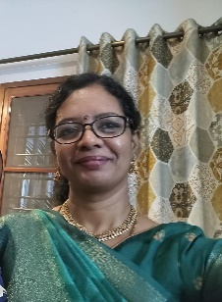

I am amazed at the level of commitment the Law Park Education Trust puts into responding to a certain community of the society.
It's a privilege to be a part of a trust that provides free education, fitness programs, books, gadgets, apparels, monetary and other benefits to economically backward students in rural areas.
Thank you for all that you guys are doing and keep up the great work
Ramya Balaji
Music Instructor

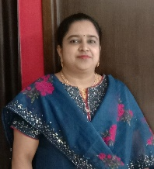

Charulata ji and Manjunath ji, you are highly motivated to do good for underprivileged children through Law Park Educational Trust. They make the effort to know each of the children personally and understand their problems and needs.
Mr. Nihar Panigrahi
Senior Software Engineer
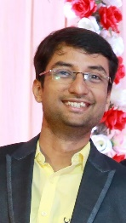

Seeing Law Park Educational Trust , makes me realise that I must also come forward and should also participate in this very effort of Helping Children achieve their goals in terms of helping with their Education expenses, and making it a better place for the children and parents. Thanksgivings to Charulata and other members of the organization who are working hard in achieving this. It’s truly overwhelming.
Ms. Pooja Banadka
Technical Officer at IFF

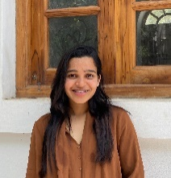

I am proud of you for the mission you have started in providing education to the poor and needy. This is such an incredible job you are doing to the society. I am happy to support and join with you in this journey of your service.
My best wishes to you and your team for all success to accomplish your mission.

Warm regards,
Krishnapriya,
Customer Support Leader,
French MNC Company.
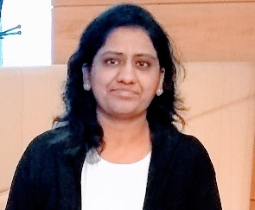

I think the organization has done an amazing job. I know how challenging it is just running a small centre like ours and appreciate the enormous effort put in by you and your team. It takes huge effort to organize such programs.
Rajesh Reddy
Advocate,
Bangalore.

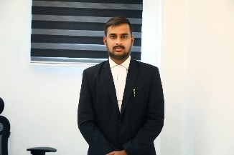

First of all congratulations to you and your team. Amazing! You have got an incredible message as blessings from a legendary person.
Have a growth wherein you serve the people in need even more better. My support and wishes undoubtedly will travel with you.

Regards
Kavitha Hari
Skybloo, Chennai.



Your service to needy children for education is noble. I am happy to donate to the cause. I am impressed by your help to poor children longing for education. I join you by my contribution.

Regards
P.V. Rangaiah.
Retired Senior Manager, UB Group
Chennai
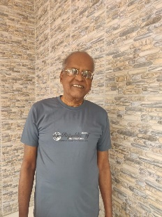

We wish to extend our sincere appreciation of your gesture of helping the needy children through scholarship I pursing their education through the Law Park Educational Trust in the greater interest of serving the society.
Thanking you once again and looking forward for your partnership in helping deserving children in the coming years for education.

With best regards
Rajan Varghese. T

I am deeply appreciative of your support to take care deserving students for the education and financial support, your generosity has inspired me to help others, I was very happy and appreciative.
Regards
S. Sumesh
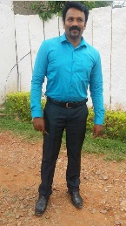

Good work very proud of you and I should thank you for making me a part in your good work.

Reshma
Rainbow Properties.
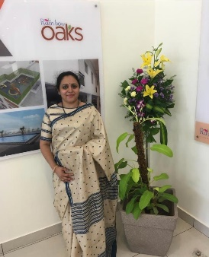

Very happy to hear that your trust is doing good.
Warm Regards
Chandrashekar.

Way to Go!! Kudos
When people find it demanding to educate one student, you are enlightening a BUNCH of underprivileged but well-deserved students. Hats off.

Sathyabrata,
Software Engineer
Orissa.
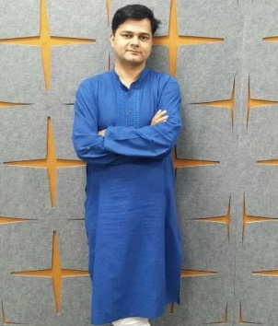

Great to hear, let me know if you need any help- anytime. I would be more than happy to be part of great work you guys are doing. Count me in as well – let me know if you have more kids

Shoban
USA

Great work Charu, very easy to think good things but only few progress to implement the good thoughts. Salute to work of Charu.
Thirunarayanan
Chartered Accountant,
Dubai.

Congratulations and proud of what you guys are doing. So proud to be associated with this organization.
Sai Prasanth
Hong Kong


Charu and Manjunatha
You are doing an outstanding service by providing education to these children. This is the contribution to people and society. Best wishes to continue your excellent services

Regards
K.V. Ramani
Founder and Chancellor of SAI UNIVERSITY
Chairman Managing Director, Digital Holdings Pvt., Ltd.,
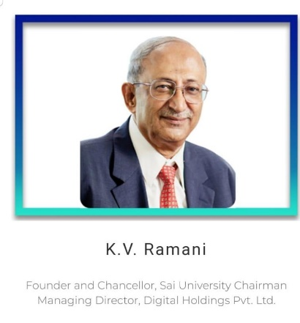

Thank you very much charulatha madam, you are doing very great and noble service to deserving and financially poor students who are unable to continue their studies. I once again thank you and your noble service.

Madhav Reddy

Ms. Charulatha,
Appreciation for the value of routine, ordinary, mundane rythms of doing work each day each week with care. Keep up the good work
R. Guru Subramanian
HCL Technologies
Delhi
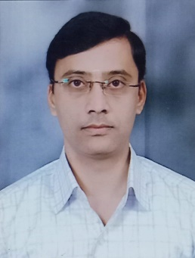

We are glad to meet a Team like yours and we are very happy for the Charitable Trust that you are running for all those children who deserve.
I congratulate entire team for being identified by the great people and it’s all because of your hard work, interest and concern on the children and also the importance of education for the children.
Let you Trust achieve more blessings by serving the needy and my support will always be with you throughout the journey.

Bhavya Shravanth
Bangalore
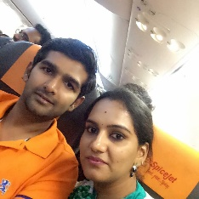
Really awesome job you guys doing and I appreciate you. Good luck for your journey.
Damodaran,
Chennai.
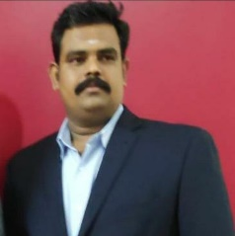

Thank you so much for the amazing job that you do. Knowing that you care for the kids giving them the confidence and reassurance.
I just hope Law Park Educational Trust will continue to be hardworking and helpful to many children as possible. I am just humbled to volunteer for the organization

Regards
Dr. Adarsh Babu,
Bangalore.
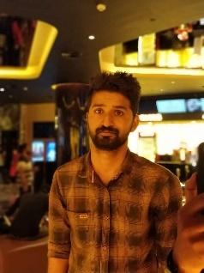

Kudos to your efforts in investing your time and energy in creating better lives for the needy and deserving children. You are not impacting the children but on a whole your efforts will create a better society for next generation to live.
Truly appreciate your efforts and good luck to LAW PARK EDUCATIONAL TRUST in this journey.
We will be glad to support you in this wonderful journey in any way possible.
Best Regards
Arun AK
CEO
INFINPRO CONSULTANTS


Law Park is striving to bring a smile on the face of many young kids and parents. I am enthralled with the team members who are working towards making this society a better place and happier by educating the next generation. I am delighted to be associated with Law Park and support their cause in making difference in people’s lives

Anand Gopi
USA
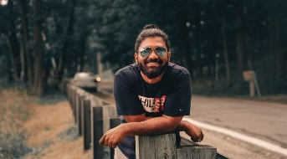

HI Charulatha,

We just do how much ever possible from our end. But you guys put in so much effort to make others life better. Keep up the good deeds.

Mamtha,

Very nice u r intention is good in the interest of weaker sector, it is needed mam, god is given very nice thought to you, only few people can do this. I am into politics, we are wasting our time with unwanted events in party but we are not supporting society like you

Ravindra
Politician

I am proud of the work that you and your team is doing towards educating the children. Your team is doing amazing work for the cause of poor and needy. The work done by your team provides education to children is an inspiration to all of us and creates a great Influence on society and Changing Minds of people for a brighter future of the Underprivileged children’s.
I am happy to join my hands to help out. My good wishes to you and your team.
All the very best!

Best wishes,
Latha s
Senior Trade Analyst
Deutsche bank

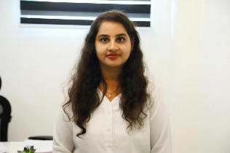

I am really happy that Law Park Education Trust try to brighten the future of children's education life especially they hand pick children with single parent, children who have lost their parents during pandemic and children from rural areas. Every year it is a boon for these parents and they can really feel secure their children education is taken care.



Jayanthi Subramanian,
Senior Manager Account management
Yatra for Business
Chennai

Congratulations, keep rocking both of you, all the best once again
Chithra Reddy
Bangalore

